**Assignment-2**

Tiffaniya C

B.Tech. – IT

7449031930

[ctiffaniya@gmail.com](mailto:ctiffaniya@gmail.com)

**1.What is function?**

A function is a block of code which only runs when it is called You can pass data, known as parameters, into a function A function can return data as a result.

Example:

*def* wel_function():  
   print(“Hai Tiffaniya welcome”)

wel_function()

**2.Difference between Build in function and user defined function.**

User defined function:

Python provides built-in functions like print(), etc. but we can also create your own functions. These functions are known as **user defines functions**.

Build in function:

The Python built-in functions are defined as the functions whose functionality is pre-defined in Python. The python interpreter has several functions that are always present for use. These functions are known as Built-in Functions.

**3.What is Enumerate function?**

Python eases the programmers’ task by providing a built-in function enumerate() for this task. Enumerate() method adds a counter to an iterable and returns it in a form of enumerating object.

This enumerated object can then be used directly for loops or converted into a list of tuples using the list() function.

**4.Use of getattr() and setattr().**

getattr():

Python **getattr()** function is used to access the attribute value of an object and also gives an option of executing the default value in case of unavailability of the key.

Setattr():

**Python setattr() method**is used to assign the object attribute its value. The setattr() can also be used to initialize a new object attribute. Also, setattr() can be used to assign none to any object attribute.

**5.Use of Id function () and Len function ().**

Id function():

In Python, the id() function is a built-in function that returns the unique identifier of an object. The identifier is an integer, which represents the “memory address “ of the object.

The id() function is commonly used to check if two variables or objects refer to the same memory location.

Len function():

**Python len() function** is an inbuilt function in Python. It can be used to find the length of an object.

**6.Write a code student mark sheet creation using userdefine function with for loop.**

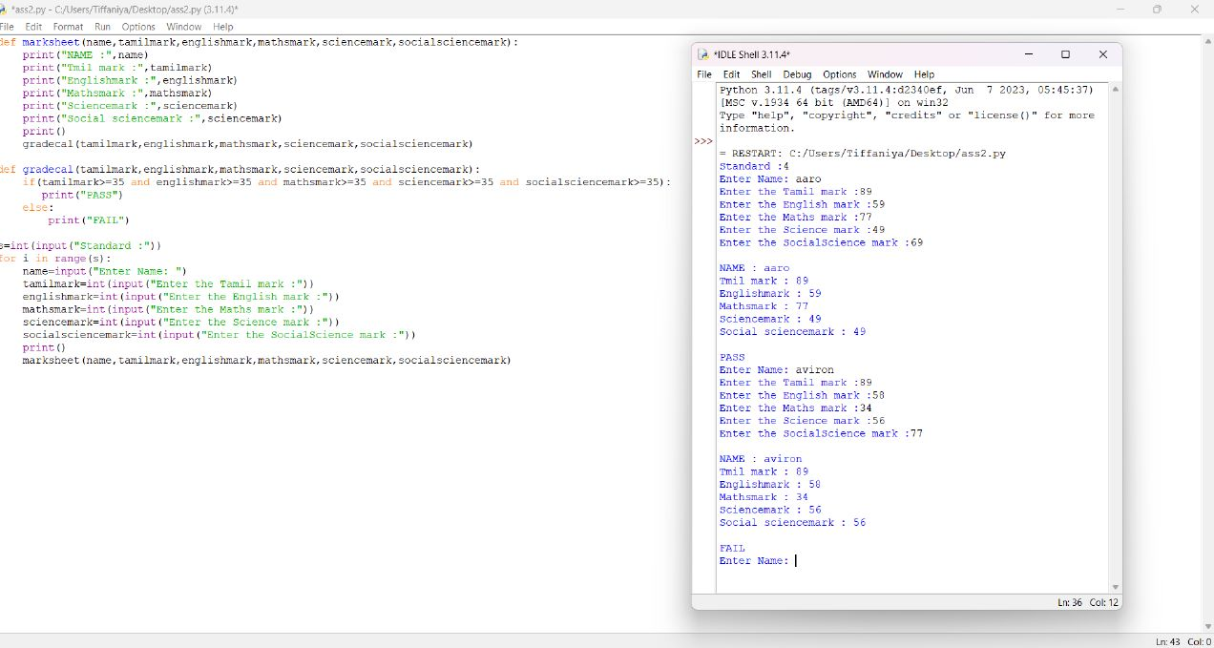

**7.Difference between type () and Input ().**

type():

The type() function is used to get the type of an object. When a single argument is passed to the type() function, it returns the type of the object.

Input():

**Python input() function** is used to take user input. By default, it returns the user input in form of a string.

**8.What is exception handling?**

Exceptions are raised when the program is syntactically correct, but the code results in an error. This error does not stop the execution of the program, however, it changes the normal flow of the program.

**9.What is try and except?**

Try:

It defines a block of code test if it contains any errors. You can define different blocks for different error types, and blocks to execute if nothing went wrong, see examples below.

Except:

Except is used to catch and handle the exception(s) that are encountered in the try clause. else lets you code sections that should run only when no exceptions are encountered in the try clause.

**10.What is lambda function?**

**Python Lambda Functions** are anonymous function means that the function is without a name. As we already know that the *def* keyword is used to define a normal function in Python. Similarly, the *lambda* keyword is used to define an anonymous function in python.